

Smart Medicine Reminder Box

Student Name | Student ID
Damian Xavier | SA24 610865
B.W.T.T De Silva | SA25 610161

Supervisor: Mr. Dilanka Wijesena
Year 1/ Semester 2
Software Development for Embedded Systems

November, 2025
Table of Contents
1. Introduction 3
1.1 Aim and Objectives 3
2. Design 4
2.2 Hardware 4
2.2 Software Design 5
3. Results and Discussion 6
4. Conclusion 7
5. References 7

Introduction
Forgetting to take medicine on time is an issue that most people have faced at multiple times in their lives. The Smart Medicine Reminder Box solves this issue by using an Arduino Uno with an RTC module and alarm system to alert users visually and audibly when it’s time to take medicine. This system that we have built, reminds users to take their medication at scheduled times by comparing real-time clock data with the alarm values set by the user. The user can easily set the alarm using potentiometers and a set button, and stop it using a confirm button. This project helps users, especially the elderly, maintain timely medication habits.

Aim and Objectives
Aim:
To design a smart reminder system that alerts users to take their medicine at the correct time.
Objectives:
• To enable the user to set alarm times using potentiometers.
• To provide both visual and audio alerts at the alarm time.
• To simulate and test the design in Proteus.
• To display all time-related data and communicate with user through an LCD display.

2. Design

2.1 Hardware Design
The hardware components include Arduino UNO, DS1307 RTC module, PCF8574 I2C module, 16x2 LCD display, two potentiometers (for hours and minutes), two push buttons (Set and Confirm), a buzzer and an LED (for Alarm). The entire circuit was designed and simulated in Proteus. The RTC module is used to get the current time and the potentiometers and the Set button is used to set the alarm time. The 16x2 LCD is used to display current time, alarm time, help communicate with user when setting alarm time and display reminder message when the alarm rings.
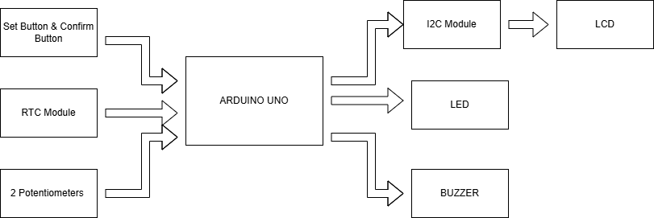
Figure 1: Block diagram
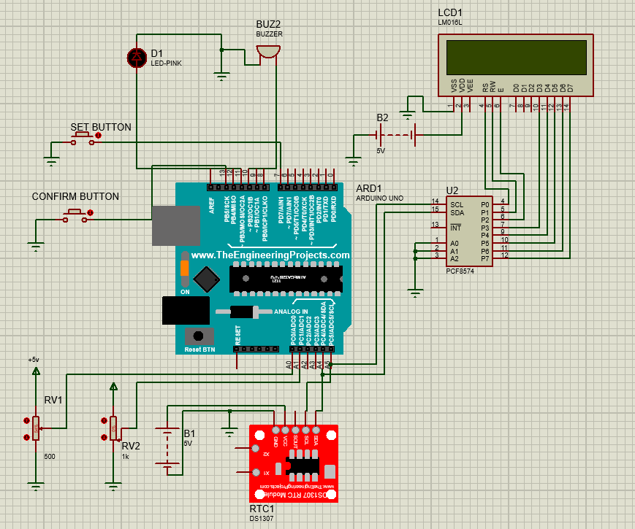
Figure 2: Schematic Diagram

2.2 Software Design
The Arduino IDE was used for programming, and Proteus for simulation. The system reads real-time data from the RTC (for simulation purposes we set the RTC time using rtc.adjust function), compares it with user-set alarm time values, and activates the alarms (Buzzer, LED and LCD display) when both times match.

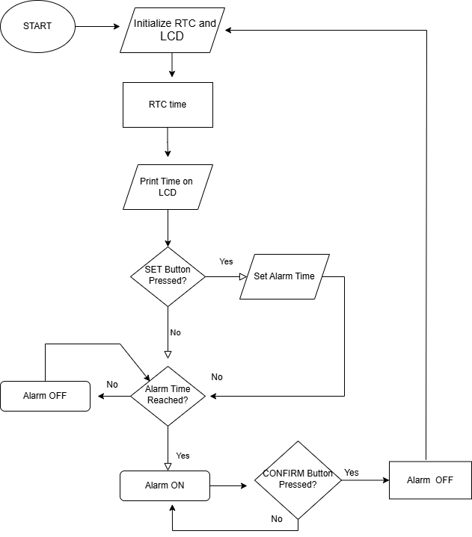
Read RTC value
Figure 3: Flowchart of System Operation

3. Results and Discussion
The system functioned as expected in Proteus. The current time was accurately displayed on the LCD. The alarm time was set using the two potentiometers (one for setting the hour and the other for setting the minute) and when the current time became equal to the alarm time the alarm was triggered. When the alarm was triggered both the LED and buzzer operated correctly and the LCD also displayed a reminder message until the confirm button was pressed. After the confirm button was pressed the LCD goes back to displaying the current time once again.

Test Condition | RTC Time | Set time | LED/Buzzer sate | User action
Before Alarm time | 11:59 | 12:00 | OFF | -
At Alarm time | 12:00 | 12:00 | ON | Take medicine Press confirm
After confirmation | 12:00 | 12:00 | OFF | Set time for new alarm time if required
Table 1: Test Results for Alarm Operation

4. Conclusion
The Smart Medicine Reminder Box successfully achieved its objectives. The system can be used to remind users to take medicine at precise times and is simple to use. Future improvements could include multiple daily alarms, data logging, or integration with mobile apps.

5. References
[1]
“RTClib,” GitHub, Sep. 20, 2021. https://github.com/adafruit/RTClib
‌[2]
J.Rickman, “LiquidCrystal_I2C,” GitHub, Oct. 01, 2021. https://github.com/johnrickman/LiquidCrystal_I2C
[3]
C. Gode, M. Narlawar, M. Thakare, N. Lakade, P. Parate, and S. Kayarkar, “Smart Medicine Reminder Box,” 2024 2nd International Conference on Emerging Trends in Engineering and Medical Sciences (ICETEMS), pp. 71–74, Nov. 2024, doi: 10.1109/icetems64039.2024.10965105.
[4]
The Bright Light, “Interfacing DS1307 RTC With Arduino UNO With Code and Circuit || Proteus Simulation,” YouTube, Jan. 20, 2023. https://www.youtube.com/watch?v=cPcJNhXd-vk
[5]
Atopet Automations, “STOP the I2C Confusion! Simulate LCD with PCF8574 in Proteus (Correct Address Explained)",” YouTube, Jun. 14, 2025. https://www.youtube.com/watch?v=0u0lIQrxgHo
‌

‌

